

**Universidad Autónoma de Guadalajara**

Biomedical Engineering

Architecture of Microcontrollers

*“*Project: CPR Mode Automatization for an Intensive Care Unit”

Andrea Alejandra Mondragón Olivos

2915351

Jesús Arnoldo Zerecero Núñez

2885993

“Project: CPR Mode Automatization for an Intensive Care Unit”

**Introduction.**

Intensive care units are used in areas where delicate patients need to be looked out for. For this reason, this units must include different modes to position the patient for which the bed must be moved manually. In addition, this beds include a CPR mode in which the bed is lowered and placed parallel to the ground, in order to apply CPR to the patient if ever needed.

This CPR mode must always be manually enabled by pressing a button or removing some locks. The nurse must wait for the bed to get into position before applying CPR, which is a waste of valuable time. So, our proposal consists on implementing an automatic CPR mode system which constantly monitors the patient’s pulse, and whenever it stops detecting the pulse, the bed itself will move into CPR mode and emit an alarm. This way, the bed will be ready for action for when the nurses come to aid the patient. This time saving could save lives.

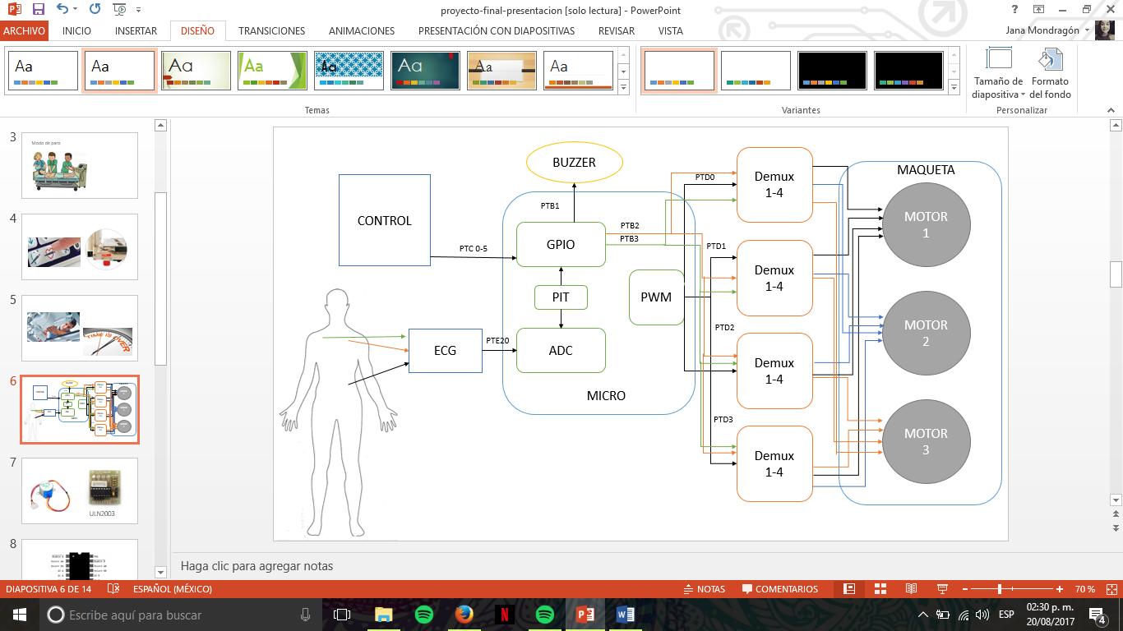

*Figure 1. The System’s Block Diagram, including the ECG circuit, the KL25z’s modules used, the alarm system and the motor’s demultiplexing.*

**Procedure.**

For this project, we used the following material:

* *Nordica* Unit controller.
* ECG Circuit (instrumentation amplifiers and pasive components).
* Special ECG Leads.
* Buzzer.
* FRDM KL25 Cortex M0+ microcontroller.
* 28BYJ-48 stepper mottors.
* Motor Shield ULN2003.
* CD4555 4-1 demultiplexors.

1. Build a high precision ECG circuit.
   1. Amplification stage with a gain of 25.
   2. 0.05 Hz passive high pass filter.
   3. 34 Hz active low pass filter, with a gain of 32.
   4. A germanium diode, to get rid of negative voltages, which could damage the microcontroller.

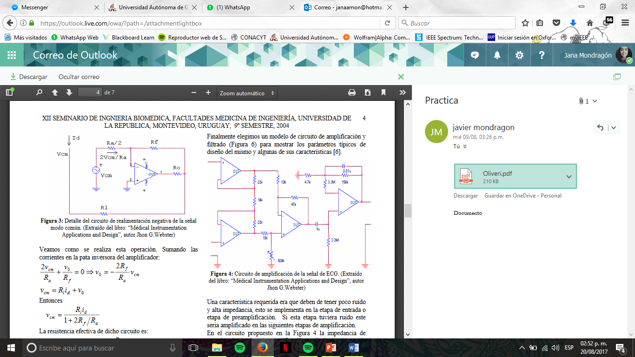

*Figure 2. ECG Circuit Diagram*

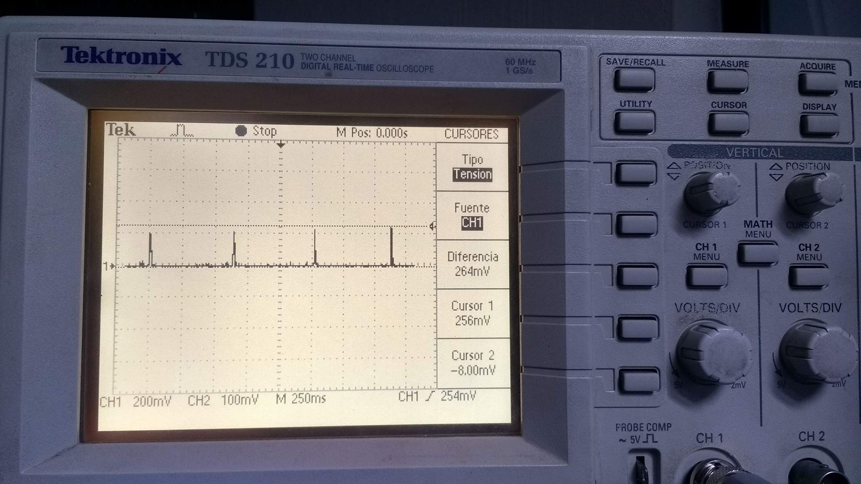

*Figure 3. Resulting output signal after going through the diode. This way the microcontroller will only receive positive peaks with an amplitude lower than 300mv.*

1. Program the microcontroller using Code Warrior, to process the ECG signal via the ADC module, receive enable signals from the *Nordica* controller and redirect them to the corresponding motor via the PWM module, and condition the activation of the CPR mode.
2. Build a demultiplexer circuit which will redirect the 4 PWM channel outputs from the microcontroller to enable 3 different motors, each at a time, when needed. The PWM signals will excite a motor’s respective coils one at a time, producing full steps which make the motor move clockwise or (thanks to the ULM2003 driver) counterclockwise.

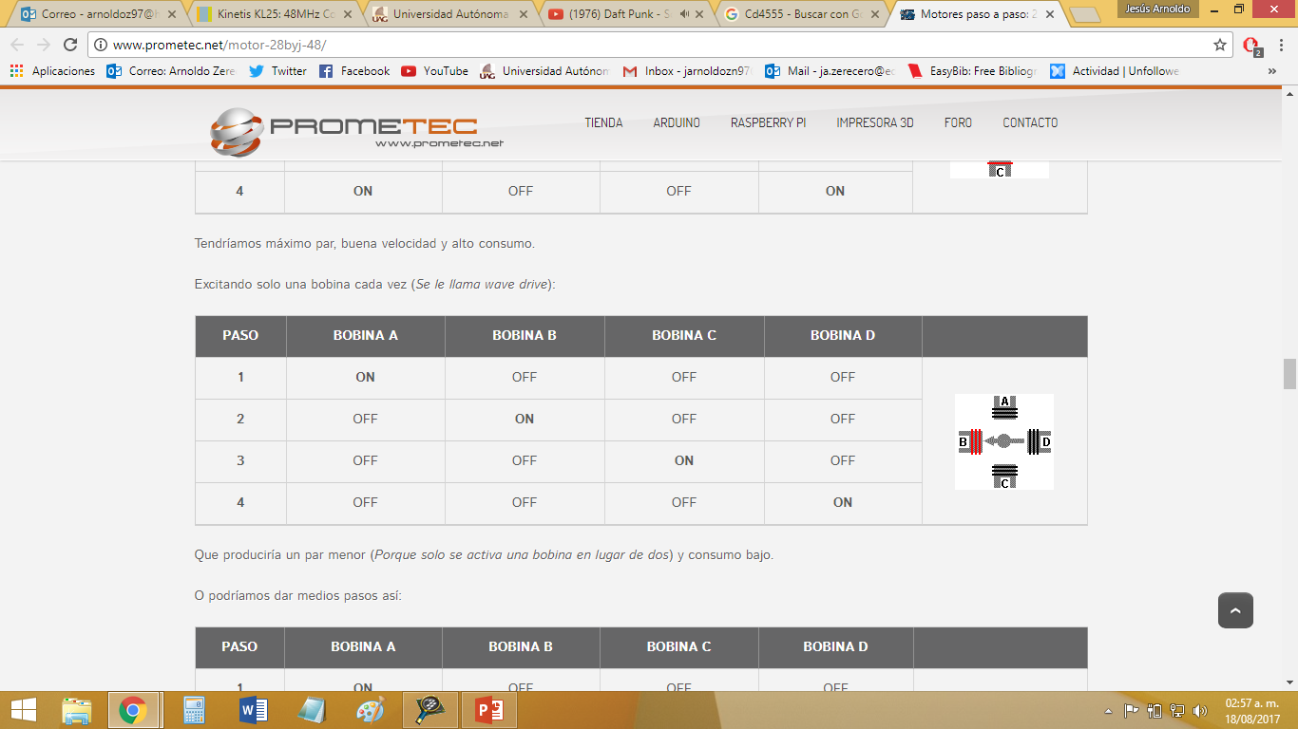

*Figure 3. Representation on how the motor’s coils must be excited in order for it to step*

1. *Build a scale model of an intensive care unit. Each stepper motor is in charge of a specific type of movement. The unit’s movements will be directed by the motors, aided by gears and hydraulic systems.*

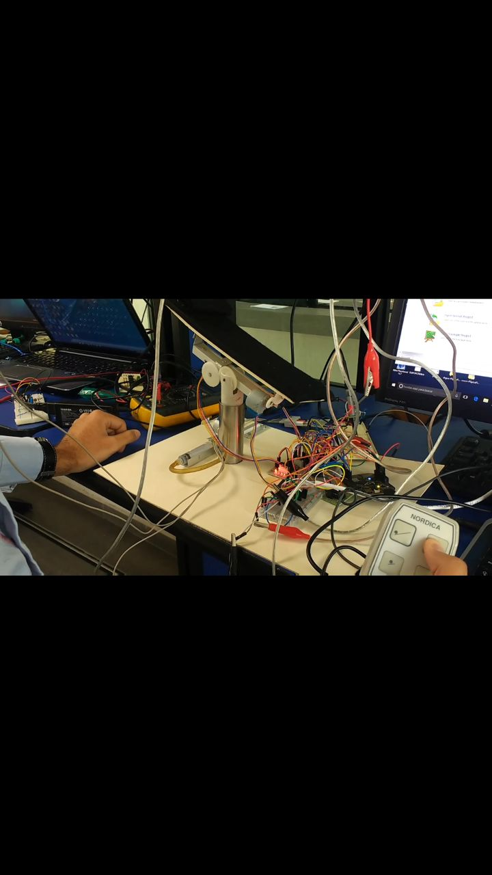

*Figure 5. The resulting intensive care unit model.*

**Functionality demonstration video:** <https://goo.gl/photos/BTt8uMBCp75sUiNJA>